**Assignment 1**

1. **Setup Billing Alarm**

To set up a billing alarm in AWS, you will need to use the AWS Budgets service. This involves creating a budget that tracks your estimated charges, and then setting up an alert that sends you a notification if your charges exceed a defined threshold. For detailed steps, you can refer to the AWS documentation or online resources that explain how to navigate the AWS Billing and Cost Management console. Remember to double-check the steps and settings to ensure everything is configured correctly.

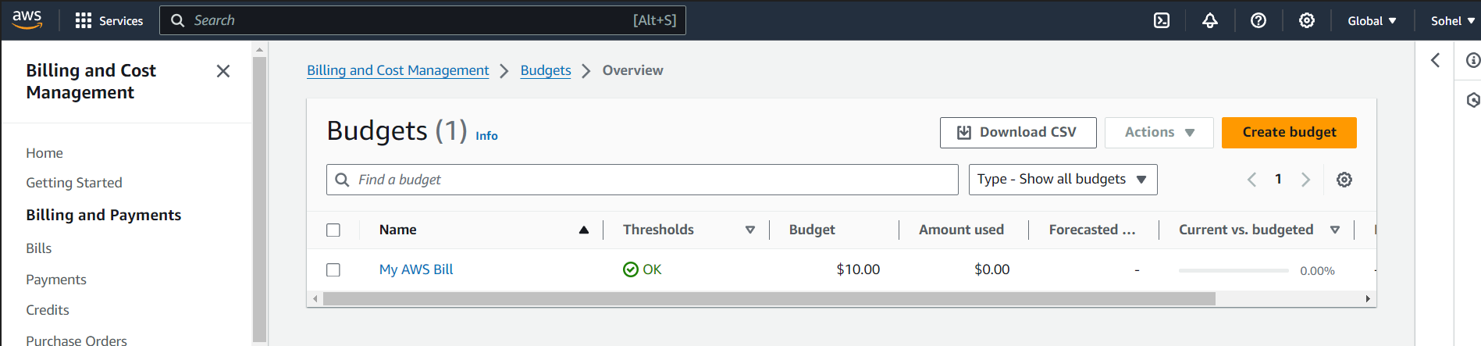

1. **Create linux EC2 instance LinuxVM-001**

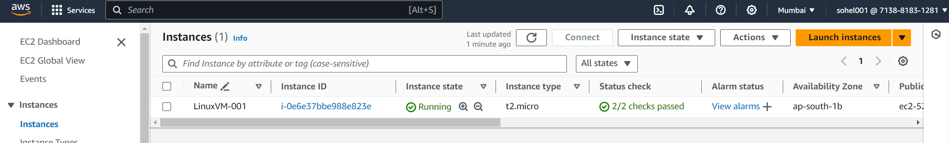

1. **Setup MFA for root user**

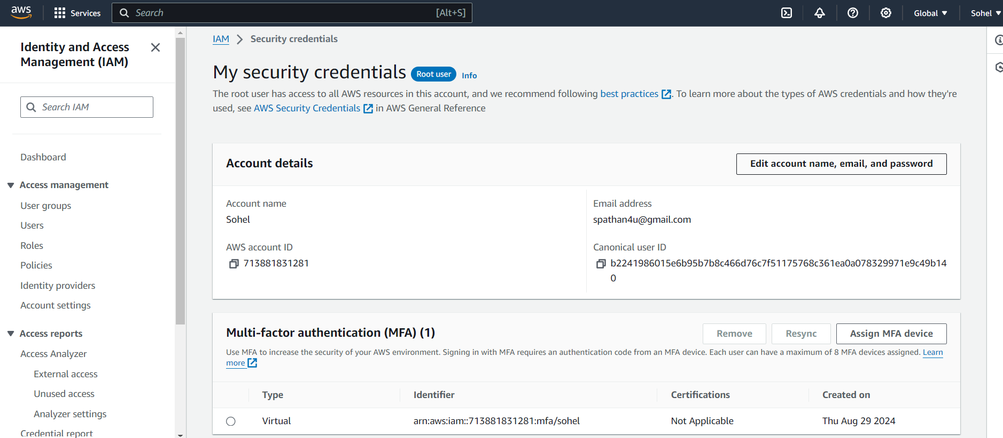

1. **Create User, Group Role using GUI**

**User**:

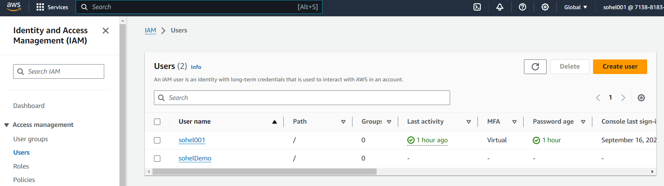

**Group**

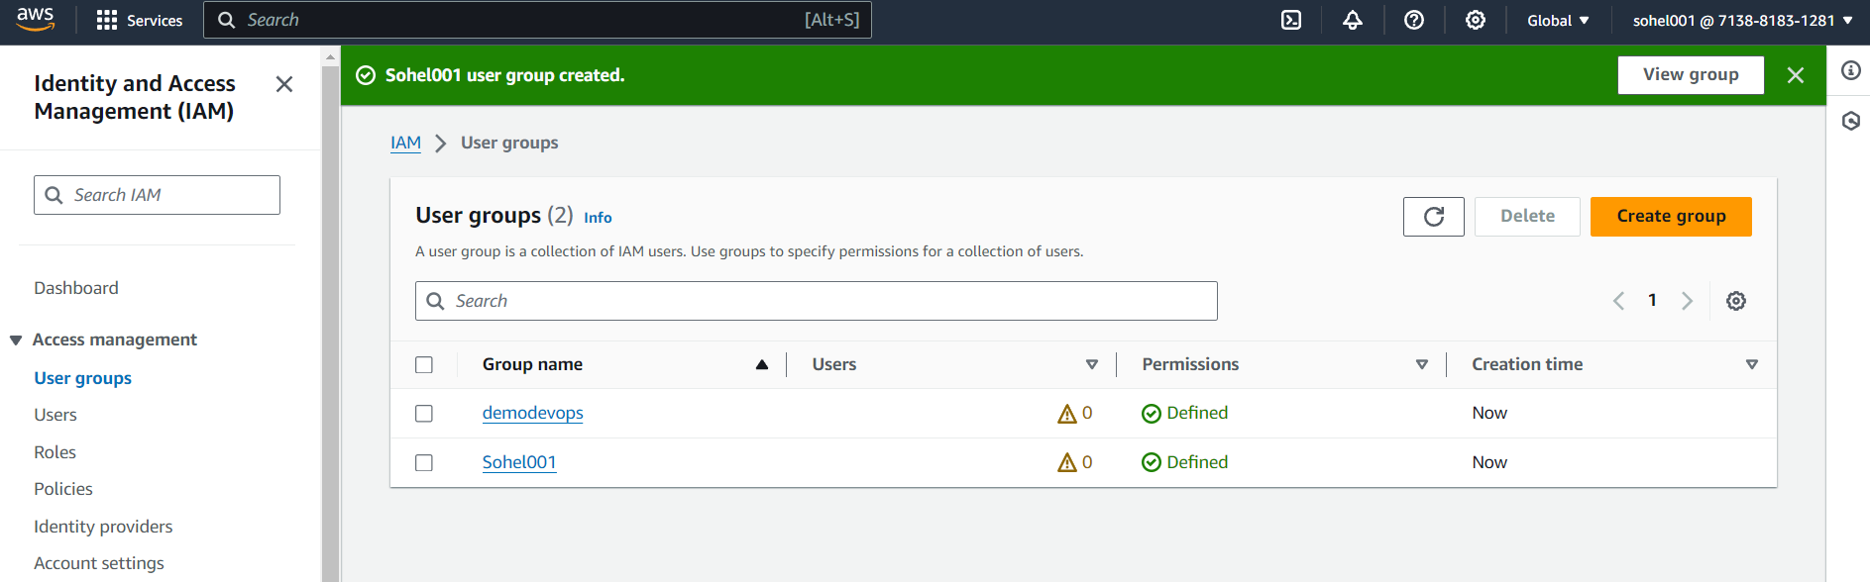

**Role**

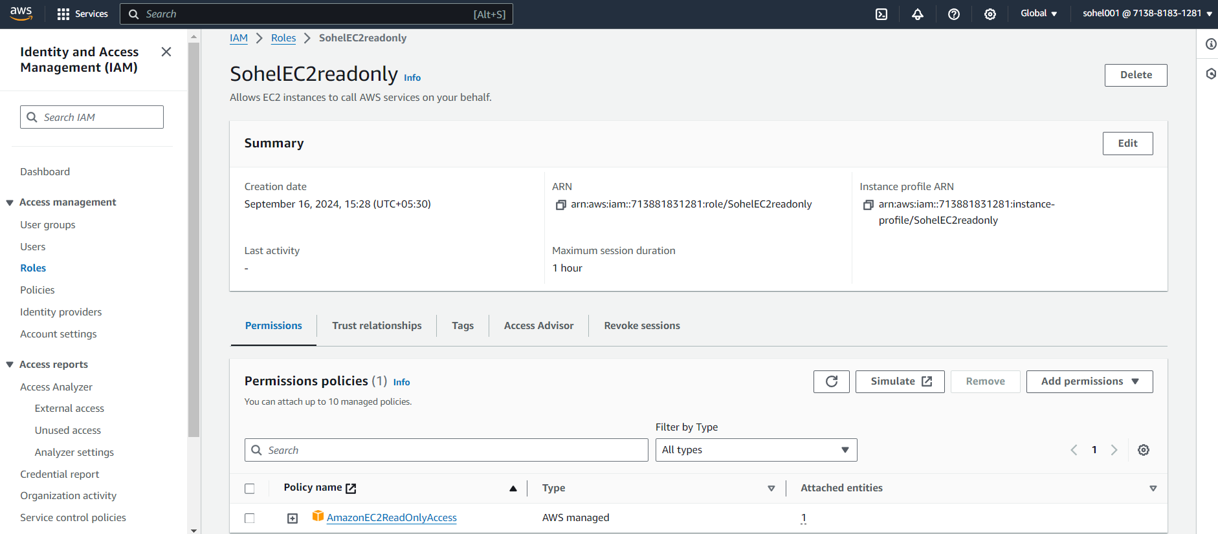

1. **Create Role Group using CLI**

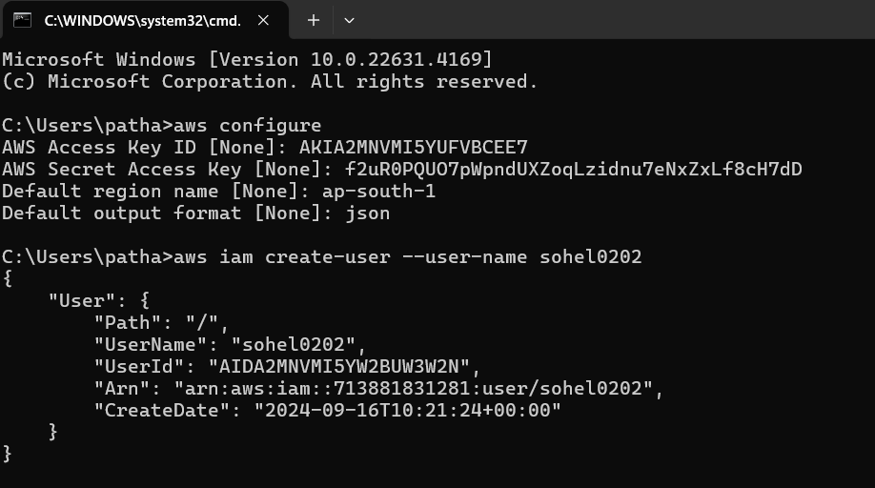

**Group**

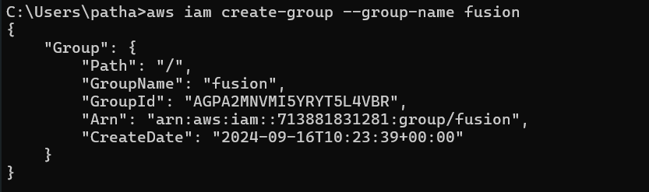

**GUI:**

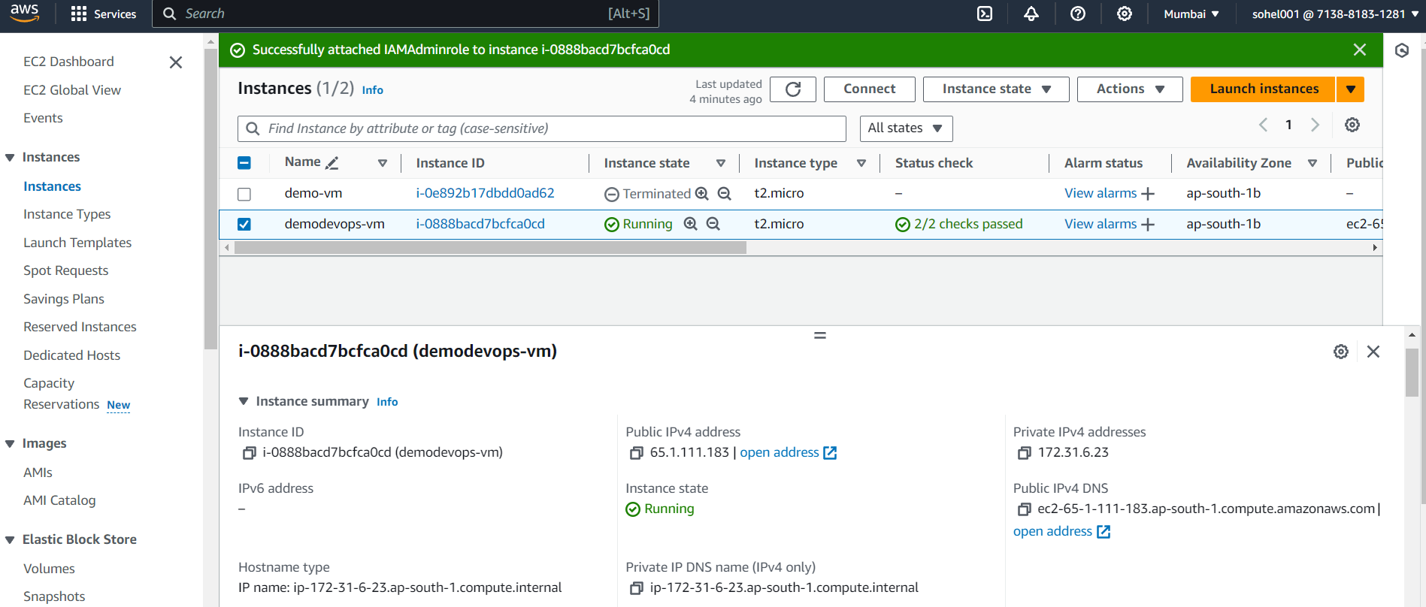

**7 . Attach role and secret access key to the instance**

**Attach role to the instance**

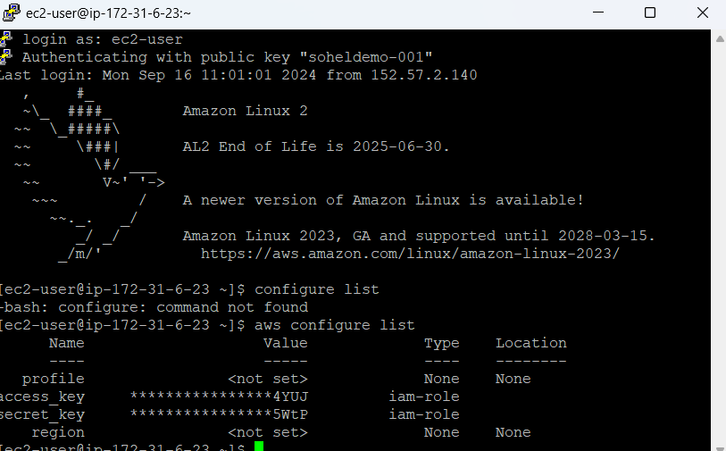

**Attach secret key and access key to the instance**

